Specialist Reviewer Overview for Hyperspace Users
Terminology:
- E-Consult: sent to a specialist clinician for review, who can send for scheduling immediately, reply with additional questions before ultimately scheduling the patient, and/or provide virtual specialty care
- Ambulatory referral: sent to a scheduler to be scheduled on a first come, first serve basis
- Ambulatory referral (outgoing only): sent to an outside, non-DPH entity for services that are not available within SFHN or when a second opinion is needed.
Who can submit:
- Clinical Support Staff (ex. RN, MA, SW, etc…) if they select an authorizing provider
- Independent Clinician (ex. MD, NP, PA)
- Trainees (e.g. residents, fellows) if they select an authorizing provider (e.g. attending)

Table of Contents
- How to: Review an eConsult (pgs. 3-4)
- How to: Send your first response to a Referring Provider (pgs. 5-8)
- Send a second response to a Referring Provider (pgs. 8-9)
- How to: Send consult to the scheduler (pgs. 9-10)
- How to: Send consult to the scheduler AND send consultative dialogue to the referring provider (pg.10-11)
- FAQ (pgs. 12-13)

How to review an E-Consult
All E-Consults are routed to specialty E-Consult pools. Each specialty E-Consult pool includes several designated specialty clinicians who serve as reviewers.
- Step 1: Open InBasket and click the E-Consults folder located on the left. The number in the parenthesis indicates the number of “new” consults in your Inbasket to review. Brand new consults are listed as “New” and are bolded. Those that are in your workqueue for over 3 days are in red font.
*You can customize your Inbasket view. Select the E-Consults folder, then click the wrench icon to position your E-Consult workspace on the bottom or on the right: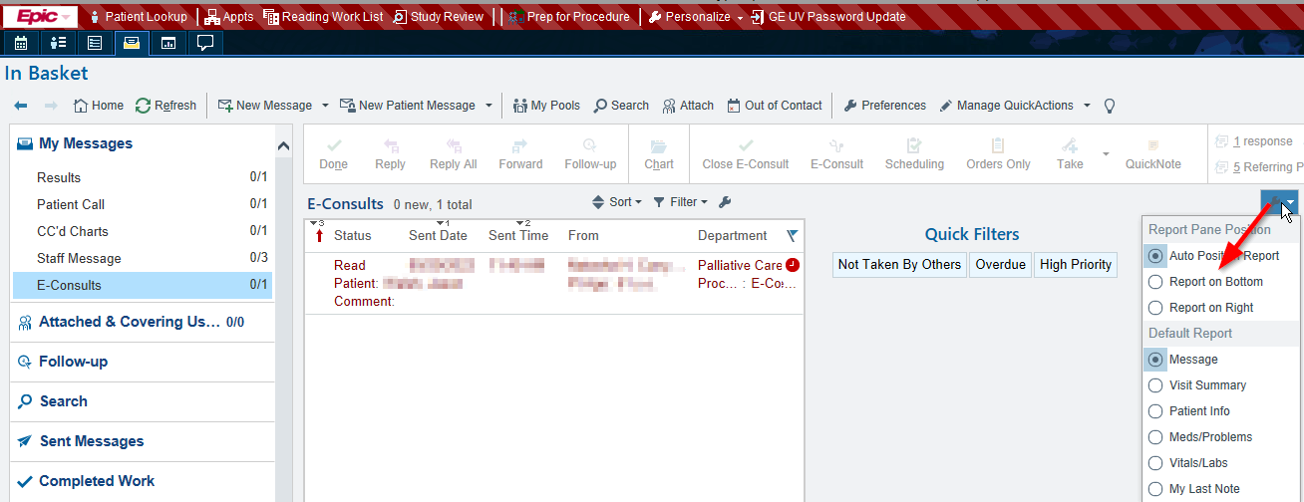

Additionally, we recommend that you sort your E-Consult work queue by Procedure (I.e., specialty to which the E-Consult was submitted). Click “Procedure” to sort. See the In Basket Quick Start Guide for more sorting tips. In the example below, the reviewer has access to Sleep Study and Pulmonary work queues. After sorting, consults to each specialty are grouped together.
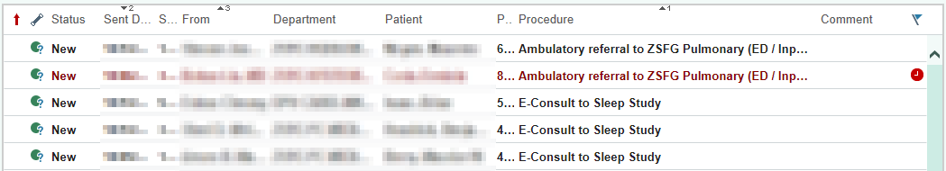

- Step 2: Single click a consult to review the reasons for consult and answers to any questions embedded in the consult order.

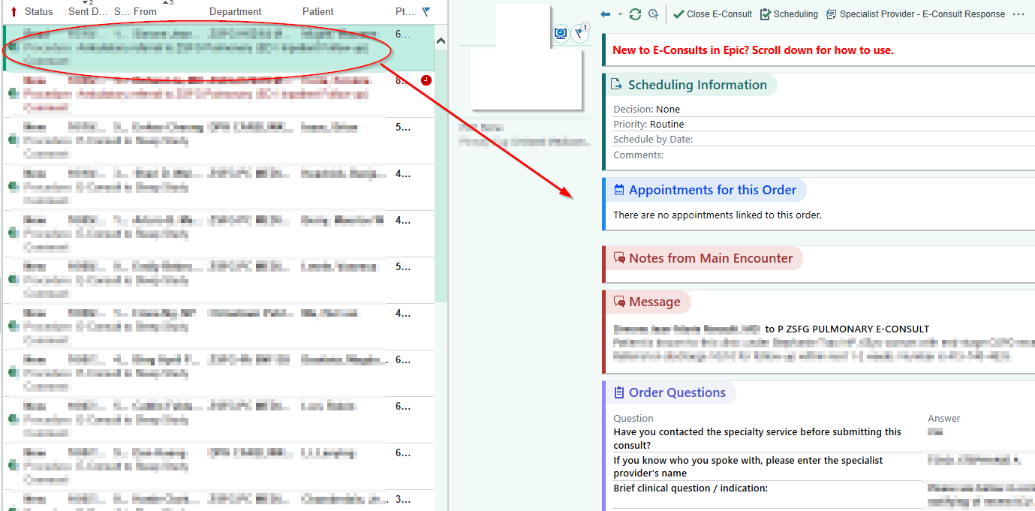
Take an action related to the E-Consult. There are 3 possible actions:
- Option 1: Respond to a Referring Provider
- Option 2: Send consult to the scheduler
- Option 3: Send consult to the scheduler AND send consultative dialogue to the referring provider
It is helpful to review the patient’s chart before determining which action to take. You can view selected components of the patient chart relatively easily, using the In Basket buttons (See yellow box on screen shot below). These buttons include:
- Visit summary: Information about the clinic visit that prompted the E-Consult
- Patient info: recent outpatient visits and care team information
- Meds/Problems: active medications, problems and allergies
- Vitals/Labs: most recent vitals and lab results
- You can also see the entire patient chart if you click on the “Chart” button on the line that includes E-Consult actions (See screen shot above) or click on the patient name. This is the most comprehensive look into the patient’s chart but does navigate you away from the E-Consult request. After navigating to the patient’s cart, return to your InBasket to go back to the E-Consult request. Then you can determine the best response option for the patient.

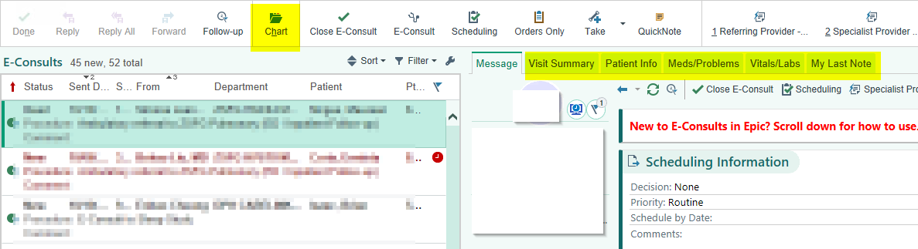
Option 1: Sending an E-Consult response
Step 1: When you have decided that this patient would benefit from an E-Consult rather than immediately scheduling, click “E-Consult” to create an E-Consult encounter
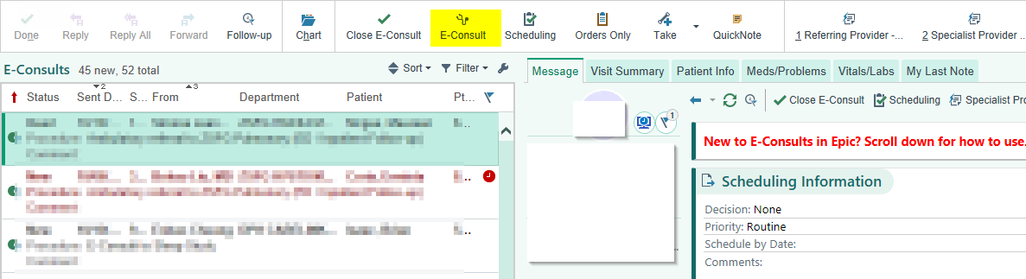

Step 2: This brings you to the E-Consult encounter. The note box automatically appears on the right-hand side of the screen where you can respond to the E-Consult.
By default, “E-Consult Order” appears in the E-Consult Visit Navigator, allowing you to view details entered by the referring provider.
The Chart Review tab is also available in the E-Consult encounter workspace.
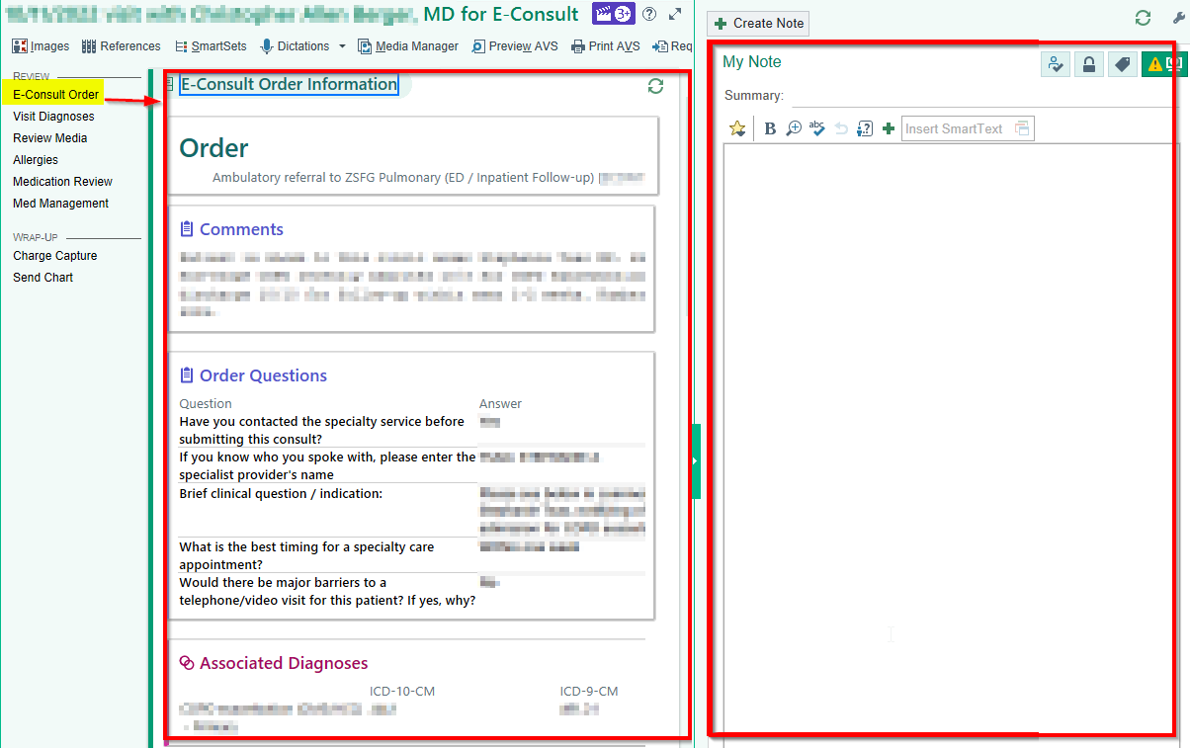
Jump to different sections of the Visit Navigator to review focused information: Visit Diagnoses, Review Media, Allergies, Medication Review, Meds & Orders. You can jump to different sections of the E-Consult encounter by clicking on these sections or scroll down to view each section one by one.
Under “Review Media” you can see any attachments that the referring provider has included relevant to the E-Consult. This may include pictures, labs results, and reports that are not already available in the SFDPH Epic system (particularly helpful for patients with primary care outside of SFDPH). You can also easily review allergies and current medications after scrolling through the Media section.
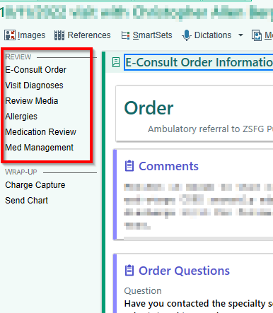
Step 3: When you have completed the E-Consult response and accepted the note in the sidebar, enter the E-Consult visit diagnosis. You have the option to manually search for diagnosis using the search field or choose from the common diagnosis options that your service has set-up for consultative notes. 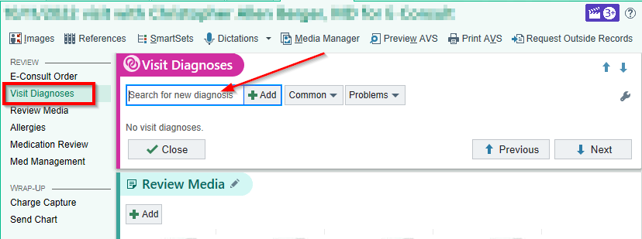

Step 4: Send the chart. The E-Consult is automatically routed to the individual whose name is attached to the encounter during which the consult was submitted. This may include a resident/fellow if the trainee changed the encounter provider to him/her prior to submitting the E-Consult. If the encounter provider is a trainee, the E-Consult response will automatically be sent to BOTH the trainee (with responsibility) and as an FYI to the authorizing attending provider.
If the referring provider is not the PCP you should add the PCP to the recipient list (see below/click Add PCP). You can also add additional recipients if applicable as an FYI.
You can also change the individual who should respond to your E-Consult by moving around the “green ball of responsibility”. By default, this is the provider who submitted the E-Consult. On rare occasions, it may be applicable to move the “green ball of responsibility” to the PCP or Authorizing provider (for example if the encounter provider is a trainee and you want to give the attending responsibility or if the patient is referred from the ED and will follow up with the PCP).
Note: Individuals who receive E-Consult responses as FYI and do not have the “ball of responsibility” cannot act on the E-Consult. They can only read it and close it. You can consider removing the Authorizing provider (e.g. attending if present) if concerned about duplicative messages.
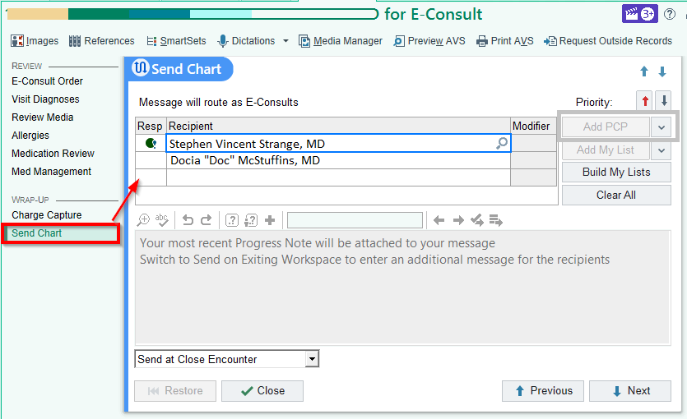

Step 5: If the consult took more than 5 minutes AND none of the following apply: you are scheduling the patient, the patient has already been seen in your clinic, there was a previous eConsult for this same problem, patient is an inpatient, the click the 5 minute button. Otherwise no need to take time to mark the zero charge button. We are not requiring charge capture prior to note closure.
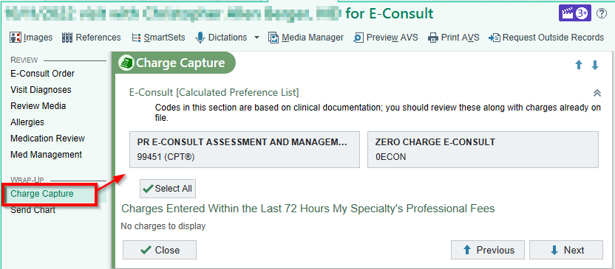
Step 6: Click when consult is complete. Note that you must assign a visit diagnosis (Step 3) before being able to sign the E-Consult encounter. Also note that charges are recommended and can be added in the Charge Capture section if you forgot and it was a consult of more than 5 minutes.
If you also want to schedule at the same time, please be sure to hit the scheduling button before signing the encounter.
After signing the E-Consult encounter, you will be re-directed to your Inbasket

Sending a second response to the referring provider
If additional communication is required after the first response:
- Go to the E-Consults folder.
- Select the E-Consult then click the “Specialist Provider- E-Consult Response” button in the toolbar (may be located under the “More” drop-down)
- Add response to Referring Provider (note you won’t be able to go back to the chart while sending this note so review the chart and decide on your response before clicking on the response button. If you do need to go back you can cancel the note and it will take you back to the chart. You can then try again after further review.
- Click “Sign and Send”
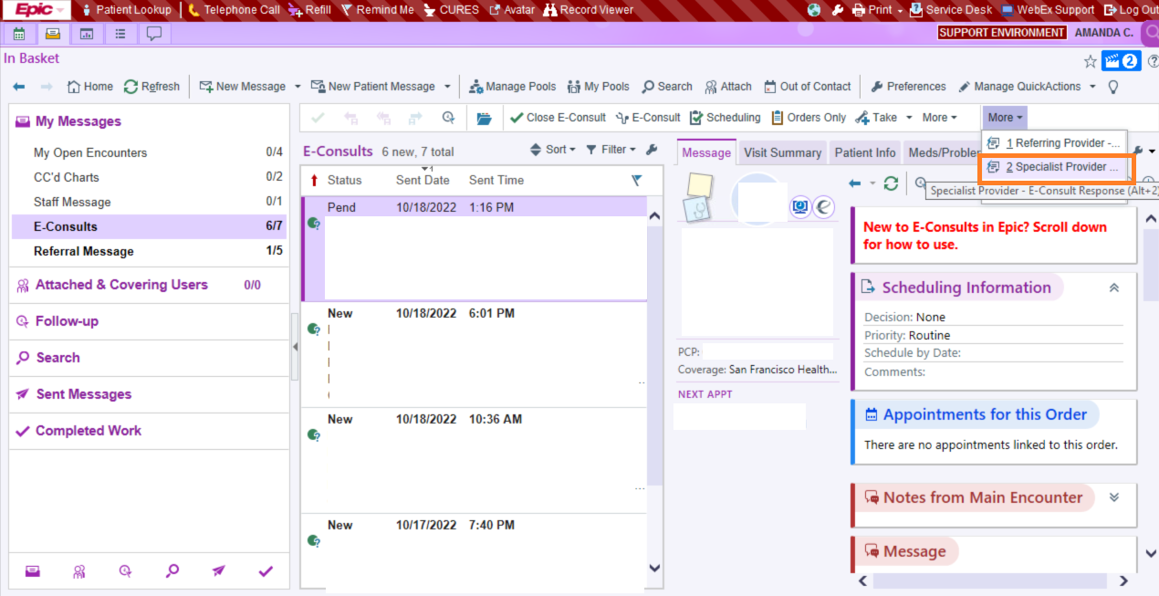
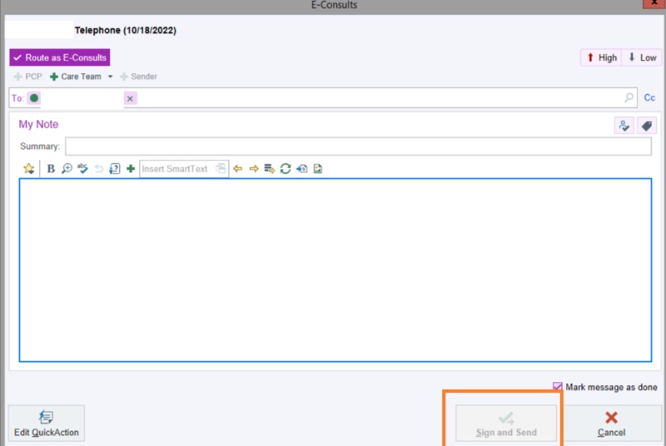

Option 2: Sending a consult request for scheduling
Step 1: After reviewing the chart at any point and you have decided that this patient would benefit from being scheduled for an in-person visit, select the “Schedule” button.
In the window, the specialty and department are defaulted. The scheduling request will go to scheduling workqueue for the department listed. If needed, change the location to where the patient should be scheduled. This is important if a specialty has clinics in two different areas (ex. 1M and 3D).
If this is an urgent request that the schedulers should prioritize, chose Urgent rather than Routine from the “Priority” drop down menu.
In Comments, provide as much detail as possible for the schedulers. Make a note of optimal timing, if overbook is okay etc. Click OK to send for scheduling.
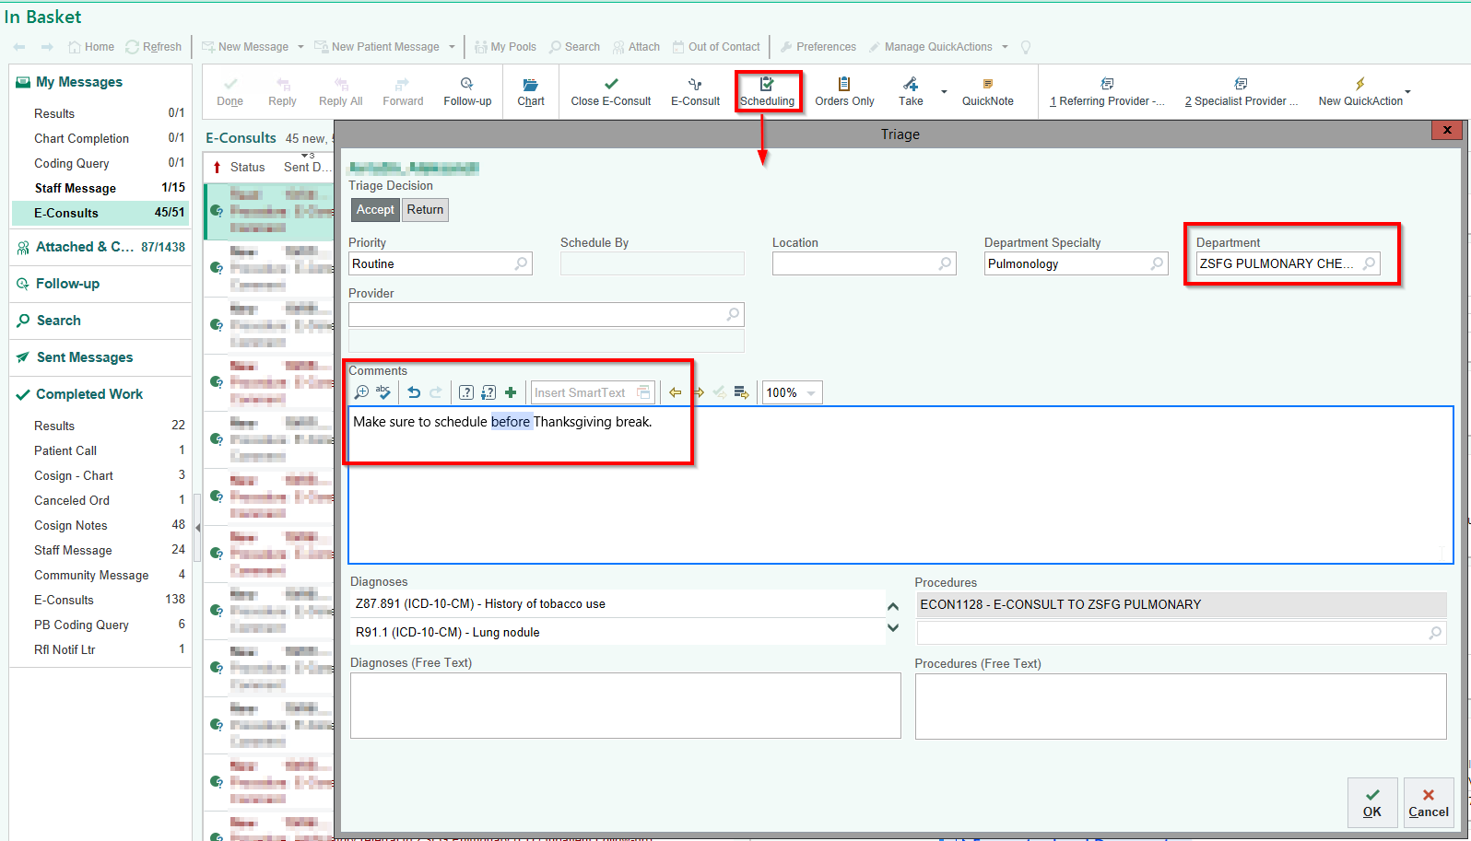

Click the “Close E-Consult” button to remove the consult from the inbasket (note: this does not affect the scheduling)
The E-Consult is done.
Option 3: Sending a consult request for scheduling AND responding to the referring provider as FYI
Step 1. After reviewing the chart and you have decided that this patient would benefit from being scheduled for an in-person visit AND you want to send one response to the encounter/submitting provider, schedule the consult FIRST by using the “Schedule” button as above.
Step 2. Respond to Referring Provider
If first response: Use the “E-Consult button” to create an Encounter
If second response: Use the “Specialist Provider- E-Consult Response” button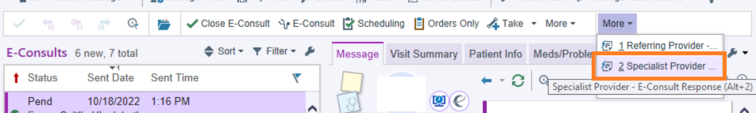

FAQ
- What do I do if the recipient box is empty and I receive this message? 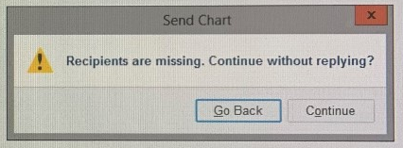
  - If you continue, your response doesn’t go to anyone and is lost in the ether. You have to find who sent the consult (typically a coordinator from one of those clinics). You can see the “Ordering User” name when replying to an eConsult. 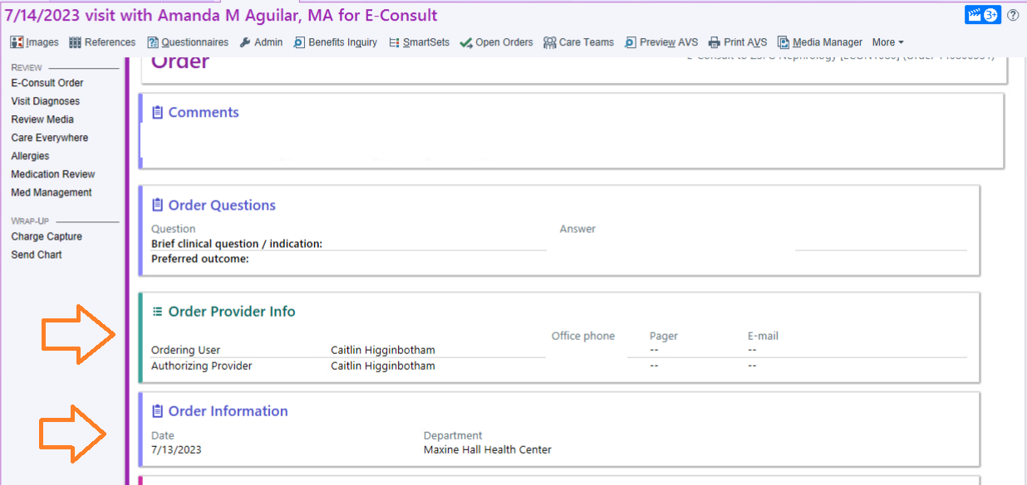
  - You then manually enter that name into the send chart section. 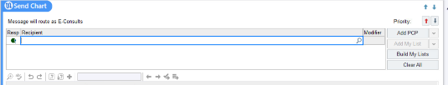
- What do I do the “E-Consult” response button and/ or “Scheduling” button is greyed out?
  - One of the following most likely happened:
    - The green ball was moved from the pool to another person which resulted in you being cc’d on the consult
    - The consult was sent you as an individual, and not the pool which removes the eConsult functionality
  - Please send the Referring Provider a separate message requesting them to send you back the consult with the green ball next to the pools name.
- What do I do if I am not covering consults and consults are NOT being sent to the covering Specialist?
  - To ensure your pool has the “green ball of responsibility” and can respond to/ schedule consults, add your specialty pool name in the recipient box
    - 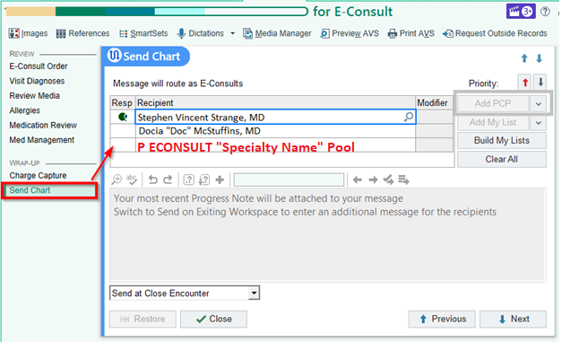
- What do I do if I receive a consult from the Emergency Department?
  - Please DO NOT respond to the ED Referring Provider. If you need to respond to the consult, please add the PCP and move the “green ball” next to their name so they are able to respond to the consult 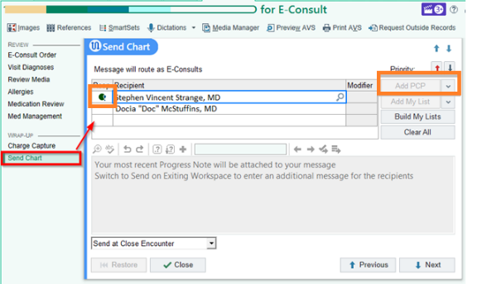
- What do I do if I am responding to the Referring Providers and want to also send the consult to scheduling?
  - Go back to your inbasket (do not sign the consult) and click the scheduling button. After you send the consult to scheduling, you can re-open the encounter to finish your response to the Referring Provider.

