How to submit a eConsult/ Ambulatory Referral for Hyperspace Users
Terminology:
- eConsult: requests for specialty expertise that are sent to a specialist clinician for review, who can send for scheduling immediately, reply with additional questions before ultimately scheduling the patient, and/or provide virtual specialty care
- Ambulatory referral: request for a patient to be seen by a specialty care service within the San Francisco Health Network; these requests are sent to a scheduler to be scheduled on a first come, first serve basis
- Ambulatory referral (outgoing only): sent to an outside, non-DPH entity for services that are not available within SFHN or when a second opinion is needed.
- Ambulatory referral to UCSF through Care Everywhere: similar to outgoing referrals but, by selecting a Care Everywhere Referral department (CERM), a smoother referral process is facilitated.
Who can submit:
- Clinical Support Staff (ex. RN, MA, SW, etc.)
- Clinician (ex. MD, NP, PA)

Support staff can submit on behalf of any independent clinician: (ex. MD, NP, PA). This clinician is considered the authorizing provider for the Ambulatory referral/eConsult order. Trainees can not be authorizing providers
Notifications about consults/ referrals
- Authorizing providers will receive InBasket notifications in 3 instances
  - When there is a reply from the Specialist Reviewer to the referring provider asking for more clarification or providing treatment/management guidance
  - When a patient has been scheduled for an in-person visit/appointment
  - As an FYI when there is a response to a trainee who submitted an E-Consult. Note that the attending/authorizing provider will not be able to act on these responses
- Trainees will receive InBasket notifications in 2 instances
  - When there is a reply from the Specialist Reviewer to the referring provider asking for more clarification or providing treatment/management guidance
  - When a patient has been scheduled for an in-person visit/appointment
- Clinical support staff will NOT receive InBasket notifications

How to submit an eConsult/ambulatory referral
eConsults are submitted just like any other ambulatory order. Most commonly, providers will submit eConsults during or after a patient visit or when performing a telephone encounter. You must be in an encounter to submit an eConsult.
- Step 1: From the Plan section of a patient chart when in an encounter, click “Add Order” at the bottom.
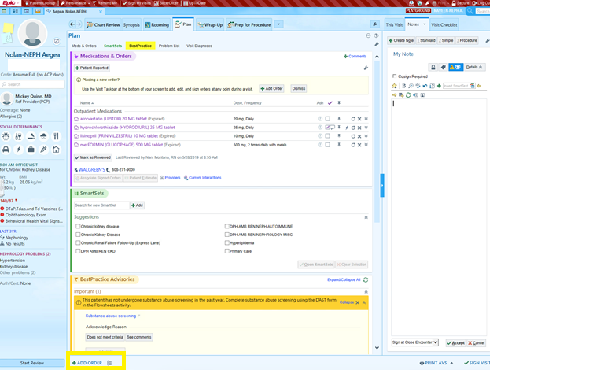

- Step 2: Search for the clinical service you would like to refer to. For example, if you type “Nephrology” in the “Add Order” field, a short list will appear that includes Nephrology eConsult (see below). If you search for “eConsult”, the entire list of eConsult services or clinics will appear (see below). Note that these appear in the tab named “Facility List”. You can also include commonly used eConsults in your preference List to facilitate easy submission. Note that ambulatory referrals to outside, non-DPH entities can be found in the Database tab. These will be listed as “ambulatory referral to XXXX (outgoing only)”

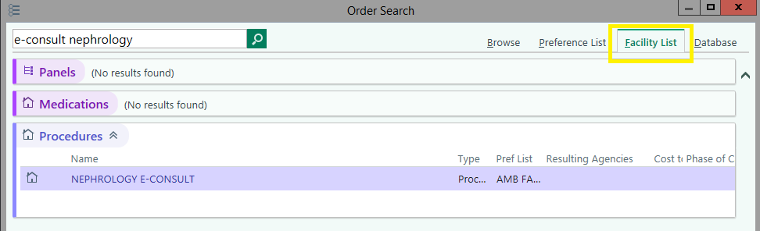
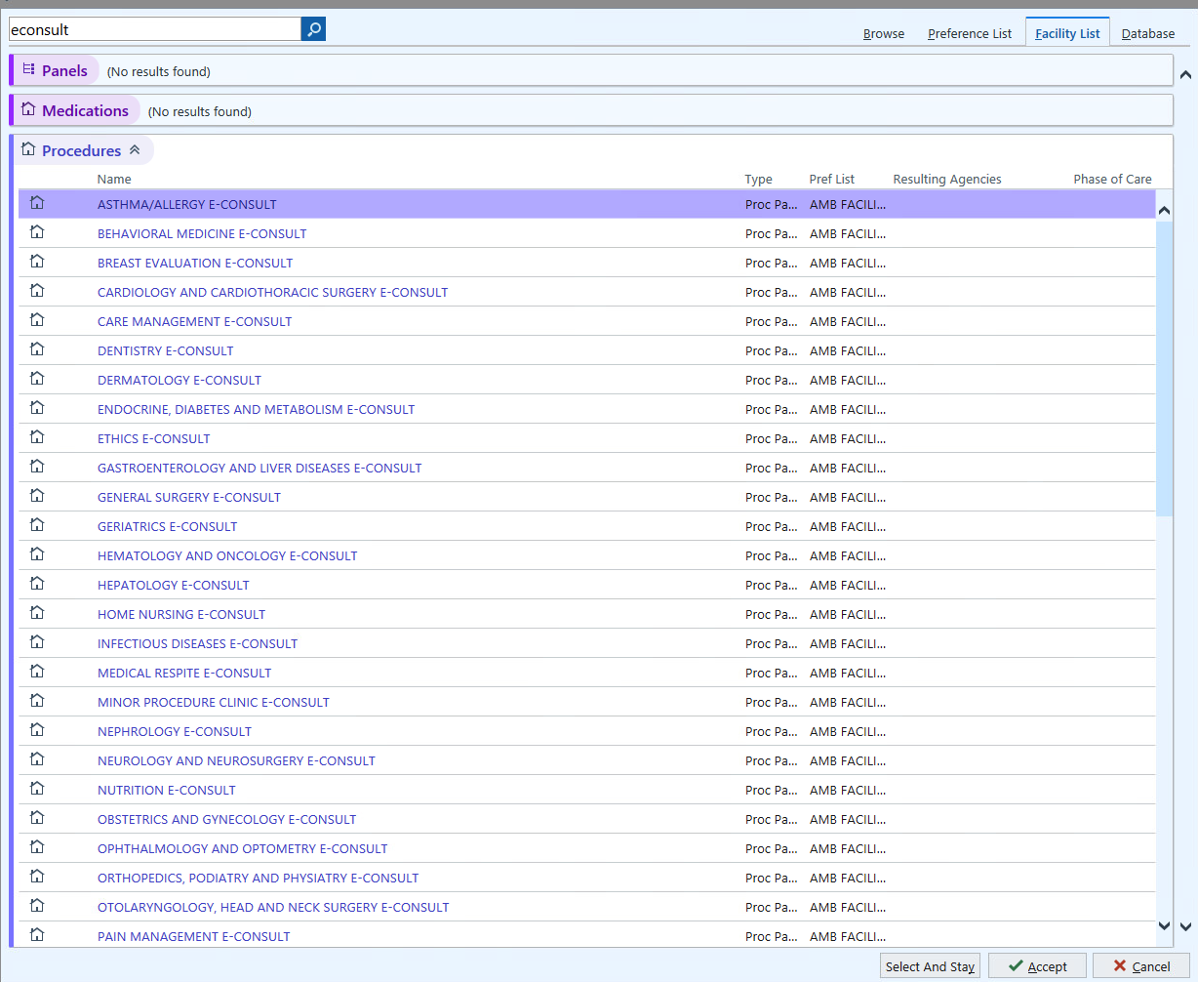

- Step 3: Double click on the eConsult of choice and click “Accept”. eConsults have been created as order panels so that you can better see the different types of services available within a given specialty. For Nephrology, there are three possibilities (i.e, ZSFG Nephrology, ZSFG Nephrology for ED/Inpatient follow-up, and LHH Nephrology).
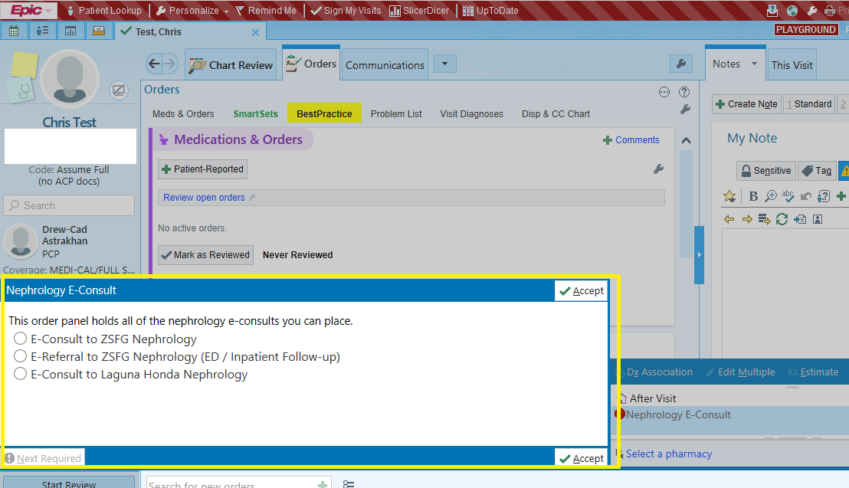
- Step 4: Choose appropriate service for your patient and answer all required questions (denoted with an exclamation point). The first question of every eConsult across the system asks for the clinical question/reason for consultation. There is very limited space in that field. To provide more history/detail please continue writing in the comment section of the referral.
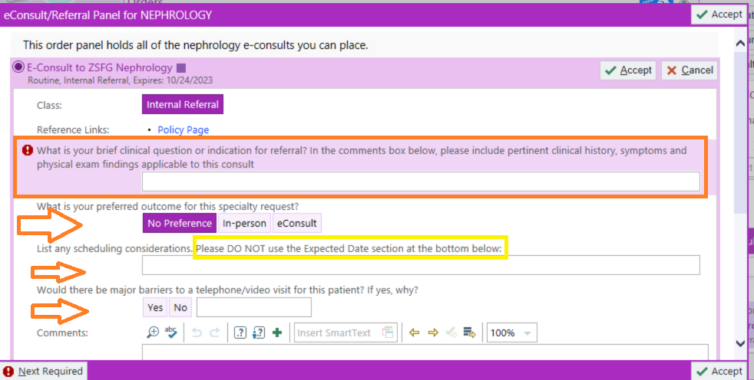
Please make sure to complete each of the required fields and questions carefully reading all instructions given for a specific specialty.
Also complete the following:
- What is your preferred outcome for this specialty request?
  - The question is currently defaulted to “No Preference”. If you DO have a preference for the outcome, please make sure to indicate “In-person” (patient needs to be seen in clinic) or “eConsult” (order is more of a consultative request, asking for recommendations)
- List any scheduling considerations
  - Please indicate any scheduling considerations (i.e. patient works certain of the weeks)
  - DO NOT USE the “Expected Date” section located at the bottom of the order
    - 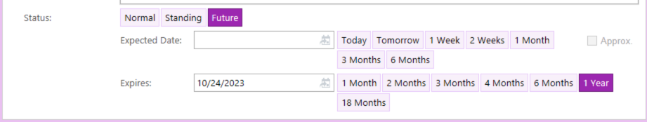
- Would there be major barriers to a telephone/ video visit for this patient? If yes, why?

- Step 5: Associate the eConsult order with an existing diagnosis on the problem list or the list of diagnoses associated with the encounter that prompted the eConsult. Alternatively, you can enter a new diagnosis/ICD10 code and click “Sign Order”
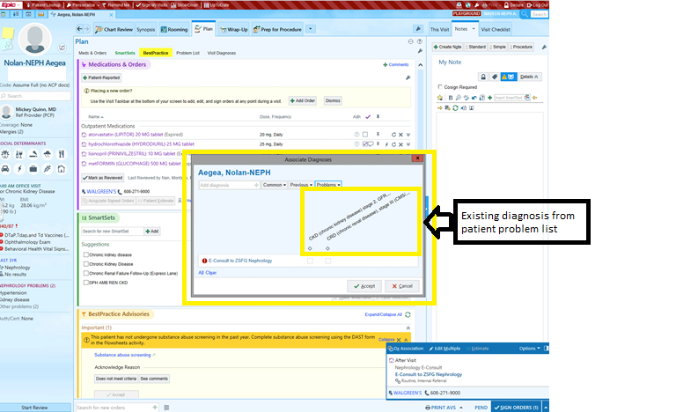

If you are a non-Provider, please make sure to fill out the following fields:
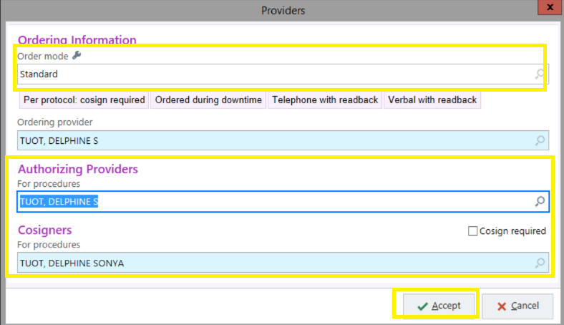

The Nephrology eConsult is now listed as an Outpatient Procedure ordered this visit and will be sent as soon as you sign the order (screenshot below)
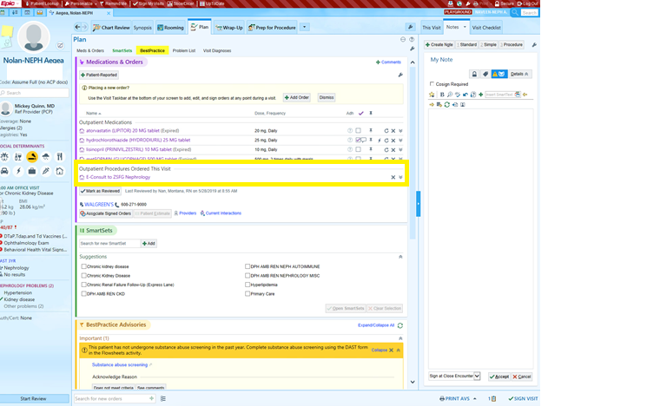

How to respond to a Specialist Reviewer
Replies from specialist reviewers will appear in an In-Basket folder named “E-Consult”. Access your E-Consult In-Basket by clicking on that folder
Brand new dialogue is listed as “New” and is bolded.
- Specialist dialogue that you have previously read is listed as “Read” and is not bolded.
- Specialist replies that remain open and are over 3 days old are in red font. That is okay if you are waiting for test results or to reply to the specialist when new information becomes available.
- The presence of a green ball icon denotes that you are responsible for taking action on the eConsult dialogue. eConsults that are in your In-basket without the green ball icon have been sent to you as an “FYI” only. You cannot take action on these eConsults but you must read them and mark “complete” after you have done so for them to leave your inbasket. This doesn’t affect the status of the consult in another provider’s InBasket. It will still remain active with the provider responsible for the consult (who will have the green ball).

Step 1. Click on the eConsult dialogue of interest. Details of that eConsult will appear on the right hand side. Note the following sections of the eConsult:
- The “Message” section includes all back-and-forth dialogue between the referring provider and the specialist reviewer.
- The “Order Questions” section includes the original eConsult question and answers to any questions that were included on the original submission form.
- The “tips on how to reply to an eConsult” section is at the bottom of the screen.
  - 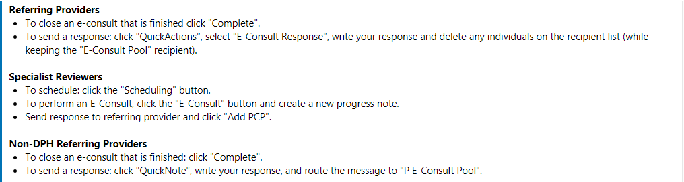
Step 2: Take an action related to the eConsult. There are three possible actions:
- Option 1. Close the encounter using the “Close E-Consult” button. We recommend closing eConsults when the dialogue is complete and no further recommendations are needed. However, remember that eConsults cannot be re-opened once they are closed, but all prior eConsults can be found within a patient’s chart.
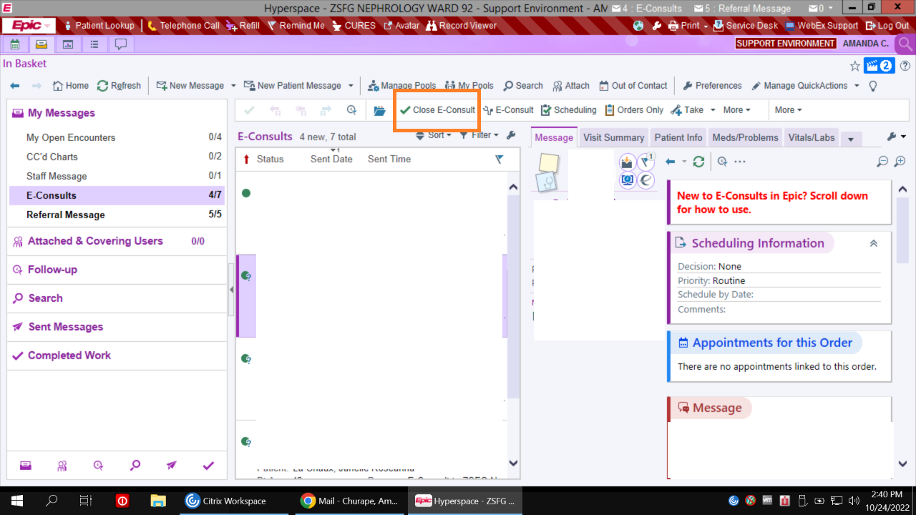

- Option 2. Reply to the specialist reviewer using the “QuickActions” button and selecting “Referring Provider- E-Consult Response”. Enter response in the dialogue box. The response will be automatically routed back to the specialty eConsult pool and the individual specialist who sent the response. If you’d like to include additional recipients as an FYI (ex. patient’s PCP), you can search for that provider or click on the “Add PCP” button. Make sure the responsibility ball is associated with the correct participant, which should most often be the eConsult specialty pool (this should occur by default). Don’t associate the green ball with the specialist who provided the initial response. They may be covering eConsults any more and then whomever is won’t be able to reply. Always send to the defaulted specialty pool. Then click “Sign & Route”.
Note: If you are listed as an Authorizing provider on a consult you will receive FYI responses from referring providers who are responding to the trainee. After reviewing this consultative dialogue, click the “Done” button. This will not affect the status of the consult in the trainee In Basket.

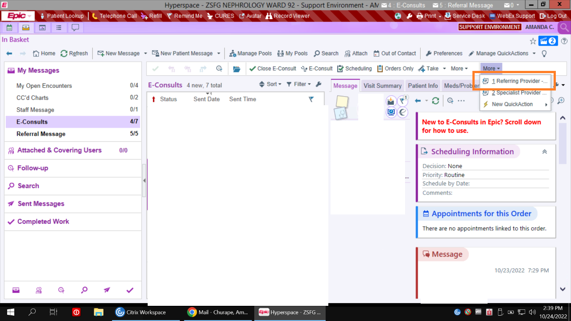
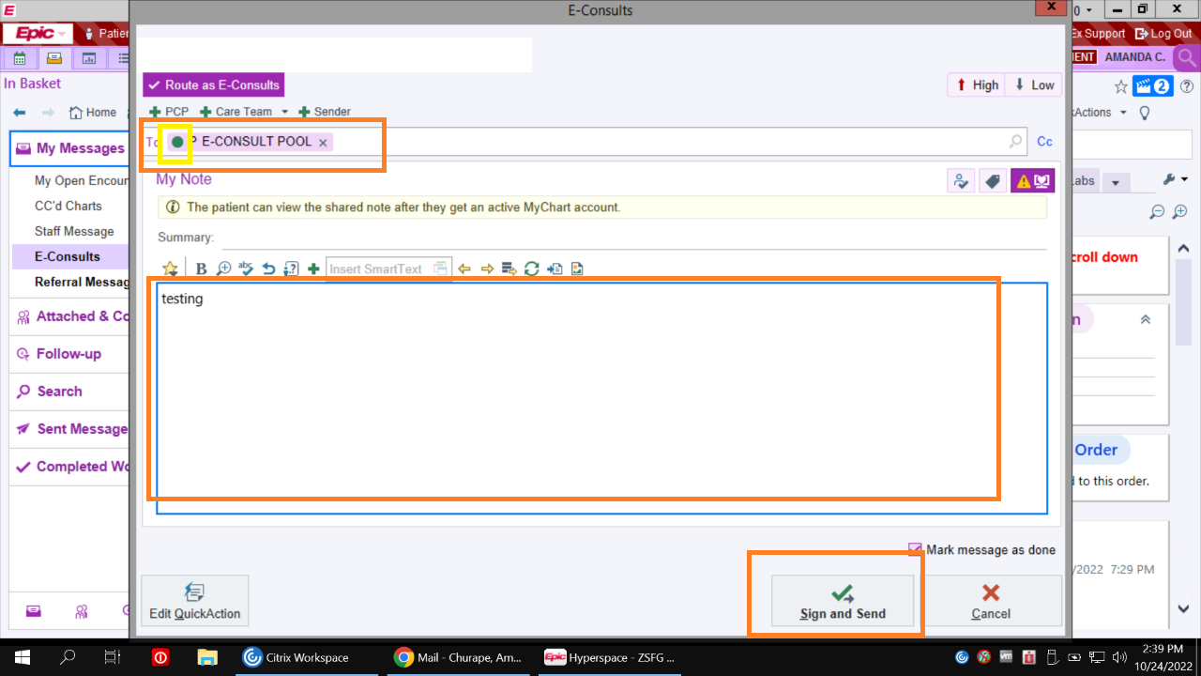
- Option 3. Do not take an action at this time and leave the eConsult dialogue open in your In-Basket while you order recommended labs or discuss specialist recommendations with the patient. Please remember that all eConsults do eventually need to be closed.
How to postpone an eConsult
- If you are asked to obtain lab tests or imaging which won’t be done for several weeks, you can postpone the e-Consult to give time for those things to happen so it isn’t cluttering your inbasket but is still avialble to provide the reply and update the specialist. This is much, much preferred from closing the eConsult and then submitting a new one.
You can postpone e-consults by clicking the little clockface icon in the task bar:
  - 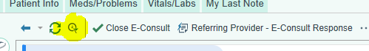
- A screen will pop up and you have the option of selecting 1 day, 1 week, or typing in date:
  - 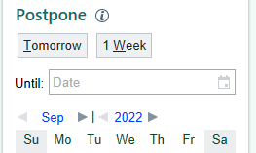
- On the specified date, the thing will pop back into your econsult inbasket, like a zombie. If you want to mess with it sooner, while it's postponed, it lives in the follow up tab to the left in your inbasket, in the postponed messages sub tab:
  - 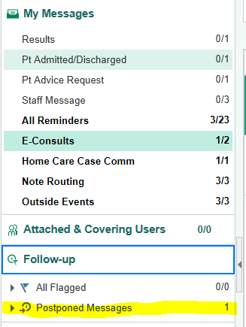
- You can play with it there, or you can move it manually back to your active econsult inbasket opening it and clicking the little left swoosh icon on the task bar:

How to leverage team-based care with eConsult functionality.
Support staff can submit eConsults on behalf of any independent clinician: (ex. MD, NP, PA). This clinician is considered the authorizing provider for the eConsult/ambulatory referral order.

Example of a Nurse submitting a consult:
After completing a consult and associating a diagnosis, the user will be prompted to:
- Add an appropriate Order mode (see screenshot below)
- Add an Authorizing provider (see screenshot below)
Note: A Cosigner is not required.
Notifications regarding the eConsult will be sent to both the Referring (Encounter) and Attending providers’ In Baskets.

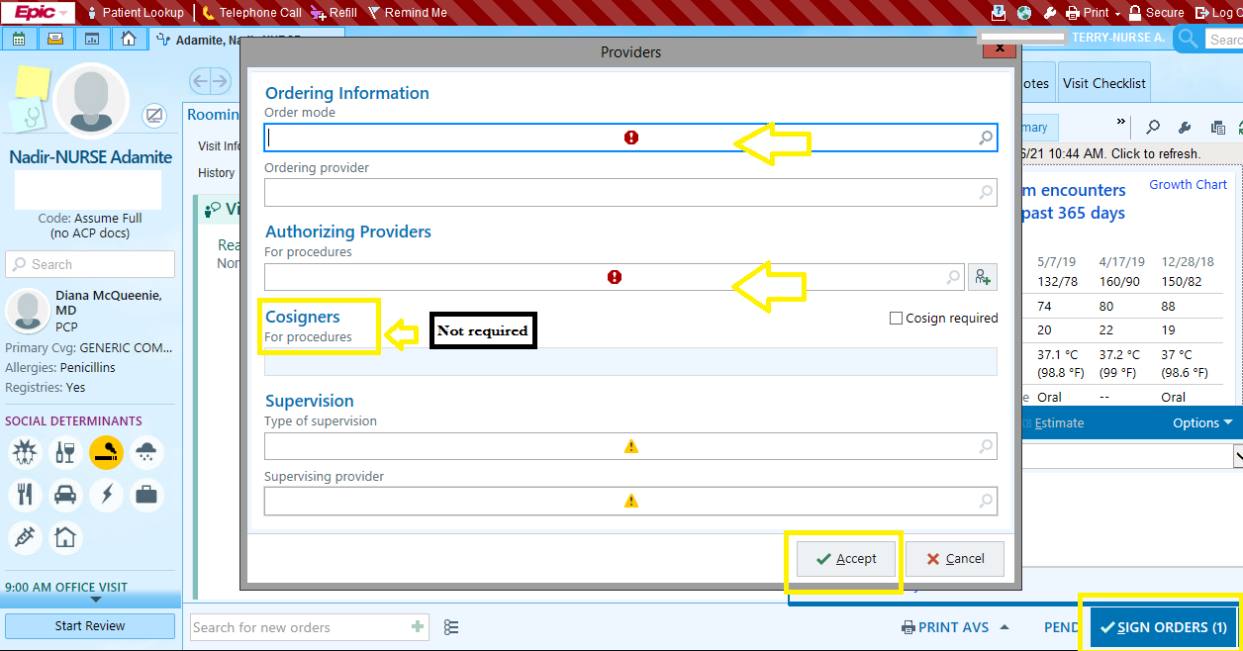
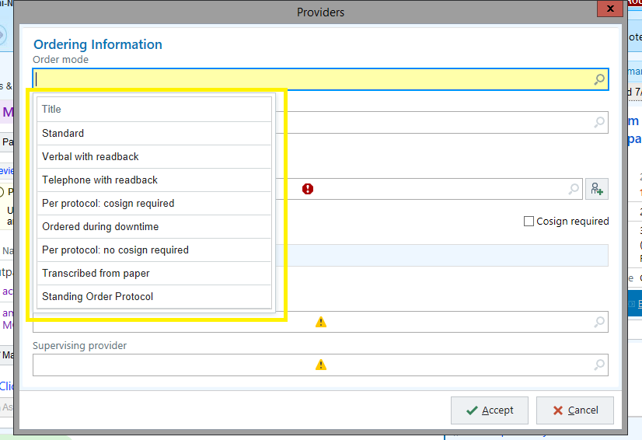

Providers have the option to attach clinic support staff to their In-Baskets to view eConsult responses and notifications. This is a one-time requirement. How to do this:
- The authorizing provider logs into Hyperspace, navigates to In Basket, and selects “Attach.”

- The provider switches to the “Grant Access” tab and enters the name of the clinical support staff (individual recipients only) who has permission to review his/ her In Basket.
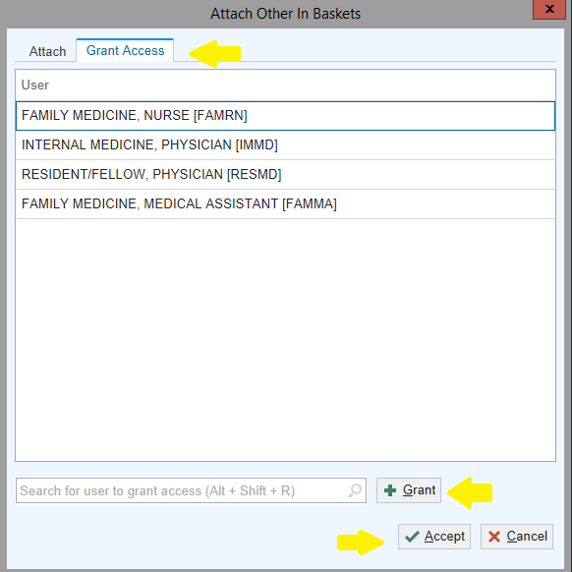
- The support staff then logs into Hyperspace, navigates to the “In Basket’ tab and selects “Attach.”
- On the “Attach” tab, the support staff selects the physician(s)’ In Baskets to attach to
